**Software Development Lifecycle (SDLC) Analysis of IBM Watson Health Systems**

***A comparative study of different types of models in the relation to* IBM Watson Health *Systems***

Aditi Sandikar

Nitte Mahalinga Adyantaya Memorial Institute of Technology, Nitte, Karnataka, India

([aditi.sandikar@gmail.com](mailto:aditi.sandikar@gmail.com), [nnm23is006@nmamit.in](mailto:nnm23is006@nmamit.in))

Keywords: Critical, Scalability, Diagnosis, Processing.

Abstract: Smart Health-care Systems like **IBM Watson Health Systems** only focuses on the efficiency, scalability, security factors. This report includes three different types of requirements model namely Waterfall Model, Incremental Model, Spiral Model and estimates their sustainability for health-care applications. All the models are assessed on different parameters such as flexibility, risk management, cost and time efficiency. This report highlights the strength and drawbacks of each requirements model and tell which one is most suitable for the development of Smart Health-care Systems. I hope this report serves as a valuable resource for researchers, architects, and software engineers interested in intersection of all the models and requirements engineering methodologies. This paper is followed by conclusion and few considerations.

Publishing: This report was submitted to *Dr. Jason Elroy Martis, Associate Professor, Department of Information Science and Engineering, NMAM Institute of Technology. Nitte, Karnataka, India*. This paper is also hosted on a GitHub repository, along with the materials used in the report.

**Content**

1. Preface
2. Introduction
3. Overview of IBM Watson Health Systems
4. Comparative Analysis of SDLC model

* Waterfall Model
* Incremental Model
* Spiral Model
* Comparison of the models

1. Requirements Engineering

* Functional Requirements
* Non-Functional Requirements
* Time Constraints
* Cost Constraints

1. Conclusion

**Introduction: -**

Smart health-care systems are a framework that utilizes technologies such as wearable devices, Internet of Medical Things (IoMT), sophisticated machine learning algorithms and wireless communication technology to seamlessly access health records of individuals, link individuals, resources, and organizations and then handle it effectively and react to the health environment demands intelligently. One of the real-world examples of Smart Health-care system is IBM Watson System. This system is developed to improve decision-making in medical diagnosis. This system designs secure platforms experiences for data needs across the entire health-care industry. These chatbots are available for the patients to store their records and suggest them about their health records. Many wearable devices are also integrated for the same.

**Key Components of Smart Health-care Systems: -**

Smart health-care systems rely on various software engineering principles and technologies to provide scalability, security and efficiency. There are various different key components. Each one of them handles a different and specific aspect of smart health-care systems. The following are the major key components: -

1. **Data Acquisition Layer**: this layer collects the necessary health-care data from different resources like the wearable devices given to patients, hospital records or the patient’s personal records.

* **IoT and Wearable Device Integration**: these wearable devices include smart watches, fitness band, medical-grade devices which records the real-time patient information on day-to-day basis. There are various different types of protocols that are used for data transmission like Wireless protocols, Wired protocols, Internet and cloud communication, and Medical-specific protocols. The communication protocols that are used are mainly wireless that are easily accessed-Bluetooth, Wi-Fi, ZigBee and many more. These protocols help in communication for effective data transmission of the patient.
* **Electronic Health Records**: this component is considered the most crucial component. It ensures the efficient patient data management, streamline workflows, and efficient health-care delivery. Some of the major features of EHR are that they store the medical history, diagnoses, medication, lab result and future treatment plans. There are some challenges faced by this component as well such as the initial cost of implementation is very high. There might be data privacy issues if the data security is not strong.
* **Hospital Information System:** this component of smart health-care system contains the data of the entire hospital or it is a software solution that is made to manage all the aspects of hospitals operations from inventory management to patient’s billing. It keeps a track of patient’s registration and appointment scheduling, the billing and insurance management, pharmacy management, bed ad all the necessary item required in the room, nursing and staff management. This component also has a list of benefits such as this increases the efficiency of the hospitals by automating workflow. It also reduces cost by optimizing resource allocation. It improves the health-care regulations. This also comes with a set of disadvantages like it requires proper training for the staff members, if the potential system shuts down the entire hospital will stop working. There is also a high risk of cybersecurity due centralized data storage.

1. **Data Processing and Management Layer**: this layer of smart health-care systems focuses that the medical data that has been entered is efficiently collected, stored, analyzed and retrieved. This layer handles a huge amount of patient’s records, sensor data, medical images, clinical reports, lab reports while maintaining the integrity and security.

* **There are some key features of this layer:** It is a step-by-step process. The first step is to collect the appropriate the data from various devices. Then it uses cloud storage, relational and NoSQL databases and data lakes to store the data collected in the previous process. Then the raw medical data is converted to structured formats using big-data frameworks. Once the raw data is altered and structured then AI and machine learning algorithms are implemented on it for predictive diagnostics. It also ensures the encryption, role-based access.
* **Big Data and Analytics**: this feature of the above layer deals with a vast amount of patient’s record, history and medical imaging and manages it. It also uses different frameworks like Apache Hadoop, Spark for processing vast amount of data. These frameworks help in detecting a patient’s disease pattern and their health trends.

1. **Intelligence and Decision-Making Layer**: this layer uses AI and other technologies to make smart health-care systems more efficient and smarter in different ways.

* **AI and Machine Learning**: This layer makes different models like disease prediction model that analyzes the symptoms and medical history of the patient, the natural language processing extracts valuable insights from unstructured medical records and convert to structured and more meaningful data and the third one is medical image processing AI model to analyze the medical images, X-rays, MRIs, CT scans for a better diagnosis.
* **Clinical Decision Support System (CDSS)**: this software helps or assists the doctors and nurses in making evidence-based decisions. This software also provides alerts and notification for abnormalities in the behavior and provides recommendations on the risk coming with it or the drugs/medicines related to it. It also integrates EHRs which provide better insights on the patient’s medical record.

1. **Communication and User Interaction Layer**: this layer facilitates the interaction between the patient and the doctors or the nurses. This provide chatbots 24/7 which helps the doctors or hospital management to understand their queries and problems.

* **Telemedicine and Remote Patient Monitoring**: this provides a video conferencing software (e.g. Zoom, Microsoft Teams, custom apps) for patients for remote doctor’s consultations from any part of the world. These remote monitoring systems continuously tracks the patients’ vital and sends alerts to the doctors to take required actions. These softwares also integrate with the IoT- enabled medical devices for better performance.
* **Mobile and Web Applications**: this feature creates applications for the doctors to access the patient’s health record, lab results, and teleconsultation tools. Similarly, it also creates applications for the patients to schedule their appointments, update and track their heath records and receive various medications alerts and notifications. There are some applications that send automated medication alerts to the patients about their appointments, lab test reminders and for emergency health conditions.

1. **Security and Compliance**: this is a critical layer as it protects comprises patient’s personal and sensitive data and ensures secure communication. This system deals with a vast amount of confidential data making them a prime target for cyberthreats.

* **Some key functions are:** that they protect the huge amount of medical data from unauthorized access i.e. ensures only authorized people to access the data. It implements different safety measures in the software like Firewall. They also provide software that tracks the path of unauthorized access and to report to the higher authorities for safety of the vast data.
* **There are some challenges also faced by this layer**: it can cause complexity due to the varying regulations used across different regions. Many employees reuse passwords to make the system vulnerable. This can happen due to lack of cybersecurity training.

1. **Maintenance and Monitoring Layer**: this layer deals with continuous updates, system reliability and system health monitoring. It focuses on monitoring so that the system is prevented from failures. They also check and ensure that the system is going through smooth operation which is very important in the smart health-care systems.

* **Key Functions are**: it tracks the health performance of the patient, tracks the uptime and how much is the resource being used. It uses different AI tools to detect the potential failures and frauds that can be caused. It also notifies the administrator about any new system updates or any new system issues faced. The issues are tried to fixed right away as slight delay can affect a lot especially related to health-care fields.
* **Challenges faced in this layer are**: if the system fails, the downtime cost is very high and this can’t be delayed as it will create a huge risk to the patient’s medical treatment. It also has scalability issues; a greater number of records may overload hospital systems.

**Comparative Analysis SLDC Models:**

There are three different model that will be discussed in the following report namely: -

1. **Waterfall Model:**

* This model is a breakdown of developmental activities into linear sequential phases which means that each phase is passed to another phase where of the phases is dependable on the other and the order is fixed. This model is less iterative and flows only in one direction (in downward) hence called the waterfall model. This approach is typical for certain areas of Software Engineering. this model has few basic and fixed phases which comprise of: -

1. System and Software Requirements
2. Analysis
3. Design
4. Coding
5. Testing
6. Operations

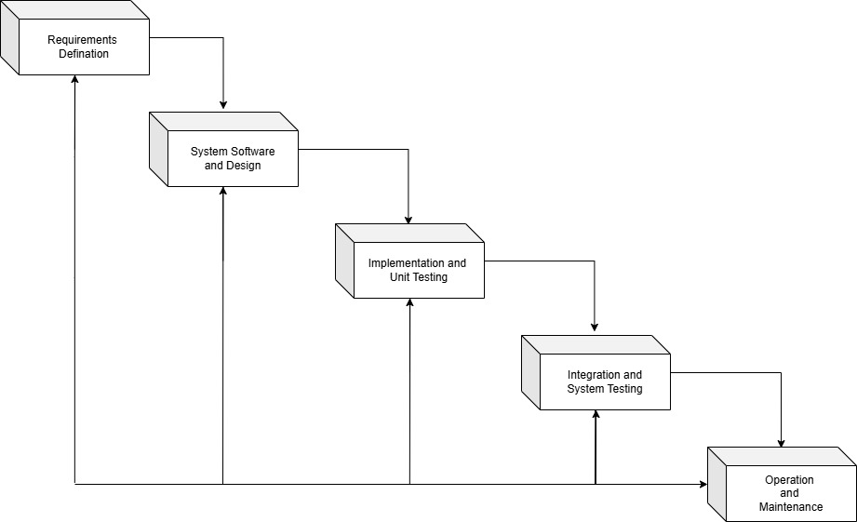**How IBM Watson Health Systems is developed using Waterfall Model:**

* **Phase 1: Requirement Design:** in this phase the key requirements are gathered from various different hospitals, doctors and regulatory bodies. All the data related to the patient is collected like the history of the patient, lab test results, medical images. All the functional and non-functional information is defined. This results in a detailed Software Requirement Specification (SRS) document is prepared.
* **Phase 2: System Software and Design:** after approving the SRS document the system design phase begins. This includes two different types of design i.e. Software design and Database Design. In the software design it identifies and gathers all the hardware and software components needed for the designing phase. It also decides whether to store the data on cloud storage or on-premise. This phase establishes network so patients, doctors and nurses from remote area can also access this software. the database design is also vey important as it securely stores all the patient records. The raw medical data which is collected is unstructured and SQL software helps to structure the data.
* **Phase 3: Implement and Unit Testing:** the implementation phase includes coding and developing the smart health-care systems based on what the design is specified. It involves frontend, backend development and database integration and AI driven analytics. Unit testing is the process of test each and every component individually of the health-care systems and make sure that they work perfectly fine for the future use. The automated tests and runs help with the maintaining the system’s reliability, security and compliance in health-care.
* **Phase 4:** **Integration and System Testing**: this phase ensures that each and every component together works efficiently and seamlessly without any disturbances and meet all the required specifications. Integration testing is the process where it checks that different modules when combined together work correctly. They also ensure that there is smooth communication between different components, it ensures that there is consistency in the data and that data is not all over the place. This phase also focuses on checking the real-time health data transmission from the wearable devices to hospital servers. This system testing also validates the AI diagnostics and predication made on the patient.
* **Phase 5: Operation and Maintaining:** after doing a successful implementation and running various different test on the system the smart health-care system enters the operation and maintaining phase. In this phase it checks that the system is running continuously for 24/7 without any disturbances and the doctors and medical advice is available 24/7 without any disturbances. It also handles all the data of the patient using smart ways like AI or IoT. This phase also ensures that it is providing a support desk for the doctors and the nurses and the patients using the system. It also involves backing up data on a regular basis so that it is available after any disaster or if in case the system shuts down.

1. **Incremental Model:** this is another type of software development model to do analysis. This model’s main motive is to divide the analysis into smaller modules which are manageable and each adding a new functionality to the system. This model is useful when the requirements are well-defined.

* There are some key characteristics of this model that needs to be followed for the effective working of this model.

1. The system in this model is built in an incremental manner and is released in multiple modules or phases.
2. This system focuses more on developing and delivered first. After each module or phase is incremented the user feedback is taken and the feedback is implemented accordingly. This model is comparatively flexible as changes can be made without affecting the entire system.
3. Since this model exports its outcome as soon as it developed the risk is known and is managed well.

* There are some pros and cons of this model that are discussed below.

1. The system can be used by the users even before the product is released or even if the final product is ready. But on the contrary due to releasing the product the users might find it use since the incremented version will have more variation and will be updated.
2. Because this model can be used at every level the problems are identified in much better way and at each step which will be helpful for the doctors and users, but this can cause delays if the issues are not solved at the correct time.
3. This model is very flexible as we can change the issues in each and every step if any issues arise. On the other hand, these all changes in each step can cost a lot of money in the long run.

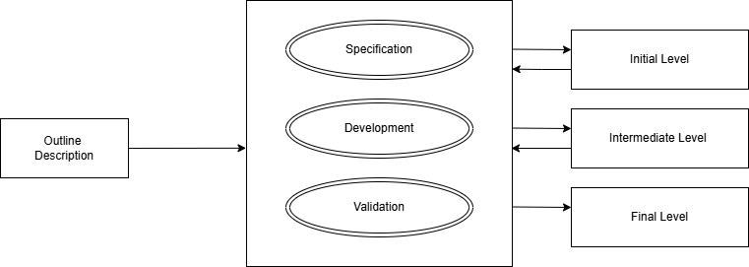**How Smart IBM Watson Health Systems is created using incremental model:**

There are various different phases in this model as well. To start with,

* **Phase 1: Basic Health Record Management Systems:** the main objective of this phase to create a system for recording or storing all the patient’s health reports and to manage appointments. The main features of this phase are that all the patients and the doctors both can create accounts and save the data related to their health records, the lab test results, medical images or the scheduling the next appointments. Since the patient’s records are stored in the system the nurses and the doctors can access them from anywhere at any given time without any difficulties. This software will only allow authorized doctors and nurses who are given the access to the sensitive data.
* **Phase 2: IoT-Based Remote Patient Monitoring & Alerts:** this phase introduces IoT-wearables like smartwatches, glucose monitors, ECG sensors etc. This can help the patient to record the required diagnosis continuously without having to check-up with the doctors or the nurses always. If there is any emergency regarding to the patient’s vitals, the software immediately sends alerts to the respective doctors and nurses. Due to this the patient’s safety is enhanced with automated alerts to the doctors. This phase also allows the doctor and patient to have an early diagnosis on the patient.
* **Phase 3:**  **AI-Powered Diagnosis & Predictive Analytics:** the main aim for this phase is to use AI/ML models and algorithms to promote in detecting the disease to provide proper health-care analytics. This phase creates AI-Powered disease prediction to detect early signs of diseases like diabetes, heart-related and cancer. This will also create chatbots for the patients that will suggests medicines, or what are the next steps to be followed or it can even detect various symptoms and try to give solutions. The machine learning algorithms will predict the likelihood of the patient. This AI/ML models will also help in providing a proper diet plan, food intake, exercise plan and medication advice for the required patient. This phase increases the efficiency in the hospital decision making.
* **Phase 4: Telemedicine & E-prescriptions:** this enables patients to connect to doctors and nurses from remote areas in case of any emergencies, hence the patients can consult from remote areas through the help of video and audio systems that will be provided in the fourth phase. This phase also helps the doctors to provide e-prescription. The system will also remind by sending SMS or by email to the patients about their next appointments and lab tests that are required. This also provides secure online payment mode for the any of the online consultations that are done during this process. One of the advantages of this phase that is avoids hospital crowding. This also helps the patient to get good medical treatment or suggestions through online consultations and digital prescriptions.
* **Phase 5:** **Smart Hospital Management & Blockchain for Secure Data Sharing:** the main focus of this phase is to heighten hospitals operations and make sure the patient’s data is secure and safely stored in the hospital records. The patients will receive the hospital and medical bills with insurance automatically with the help of the systems of this phase. The AI used in these systems also tracks the hospital supplies that are required on a daily basis and will inform or alert through message and will predict its shortages. This also makes sure that it automates the bed supply or the staff appointed for the respective patient automatically. It reduces the patient’s wait times and gives them appointments when it’s actually needed through a notification or an email.
* This was the basic structure of the incremental model and how smart-care health systems are created using this model and by going systematically taking each phase into proper consideration the following model will be scalable, efficient and is advanced in technology

1. **Spiral Model:** this is a Software Development Life Cyle model that is the combination of the waterfall and the iterative model. this model is structured in such a way that it has multiple number of loop and this can vary from project-to-project. Spiral model is usually used for complex and large software development projects. This model is also flexible and adaptable to software development.

* There are some objectives of this model that are listed below:

1. The number of loops or number of the phases that are required to develop the software is varied and is different.
2. This is model is specifically developed or created differently than the other two models observed. This model is structured like a spiral and is developed in cycles and each cycle has an increment and the product that is obtained keeps getting better.
3. The customers or the stakeholders play a very important as they provide feedbacks in each and every iteration or every phase when the software gets implemented.
4. The main reason that this model is combination of waterfall and prototyping model is because it follows the structured phases and it goes with the early testing of each and every step that is taken from prototyping model.
5. Each cycle as it moves ahead is one step closer to the final output that is required by stakeholders.

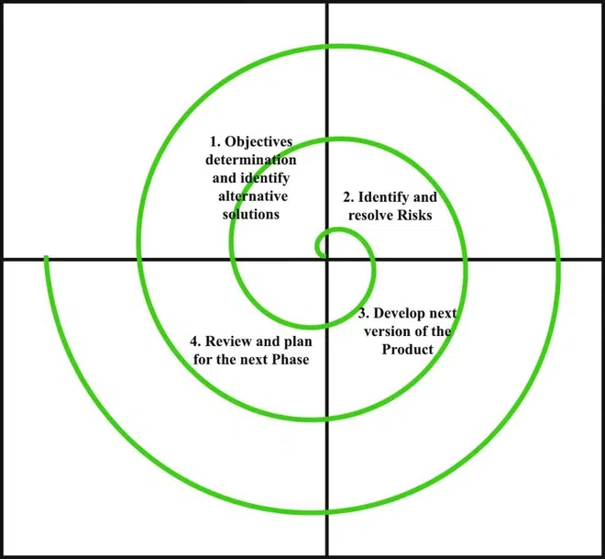**How Smart IBM Watson Health Systems is created using the Spiral Model:**

* **Phase 1: Concept and Initial Prototype:** firstly, we need to understand the requirements that the stakeholders have put in front and try to full-fill them in the following cycles of the spiral model. All the objectives, the constraints and the alternative solutions need to be defined before-hand. In this model the key stakeholders are the doctors, patients, hospitals, nurses, medical staff etc.
* **Phase 2:** **Integration of IoT & Data Analytics**: in these phase prototypes of the software are created to test them and perform risk analysis to identify all the uncertainties that are occurring in the current model. All the important parts of the software like such as the technical part, operational part or the financial part should be feasible for future use. Some smart and innovative strategies must be into this to minimize the risks that can be faced by the stakeholders. According to the above model the integration of IoT-wearables such as smartwatches, ECG sensors should be initiated.
* **Phase 3: AI Based Diagnostics and Machine Learning Integration:** in this phase the software system will expand and more and more AI- generated disease prediction. The chatbots facility is also available 24/7 for any inconvenience. There are some risks that come with this such as it can sometimes give false or negative diagnosis which will mislead to the future medical results. Considering the AI in the future it might replace the doctors.
* **Phase 4: Final Deployment and Maintenance:** to maintain the following model cloud-based infrastructure models are generated for scalability. Different software is installed like firewalls, encryption etc. to protect the confidential data or the hospitals records. This might also lead to cyber security threats which not be good for the hospital’s reputation.

These were the three models and how IBM Watson Health Systems is developed using the given three models.

**Comparison Table**

| **Criteria** | **Waterfall Model** | **Incremental Development Model** | **Spiral Model** |
| --- | --- | --- | --- |
| **Risk & Change Management** | It is **Poor** at handling changes and risks. Issues are discovered late & are costly to fix. | Has **Moderate** risk handling. Changes can be made in future increments. | Its **Best** for risk-sensitive projects, as risks are being analysed in every phase. |
| **Time & Cost Constraints** | Has **High initial cost** and **long development time.** Modifications are expensive. | It **Balances cost and time** effectively, it also allows early deployment with future updates. | The **Most expensive and time-consuming**, but ensures a **robust, failure-resistant system**. |
| **Best Suited For** | **Simple, well-defined systems** (e.g., hospital admin software, patient records). | **Applications that require continuous updates** (e.g., mobile health tracking, remote monitoring systems). | **High-risk, AI-integrated, security-sensitive healthcare systems** (e.g., telemedicine, disease prediction AI). |

**Functional and Non-Functional Requirements for IBM Watson Health System**

| **Category** | **Functional Requirements (What the system should do)** | **Non-Functional Requirements (How the system should perform)** |
| --- | --- | --- |
| **1. Patient Data Management** | **Store and retrieve Electronic Health Records (EHR). Collect real-time health data from IoT devices (wearables, sensors). Maintain secure patient profiles with medical history, prescriptions, and allergies.** | **High Availability – Ensure system uptime and 24/7 access to patient records. Data Security – Encrypt patient data to meet HIPAA & GDPR standards.** |
| **2. AI-Powered Diagnosis & Decision Support** | **Analyze structured (lab reports) and unstructured (doctor’s notes) medical data. Predict diseases (e.g., cancer, diabetes, cardiovascular issues) using AI models. Provide personalized treatment recommendations based on clinical trial data. Process medical texts using Natural Language Processing (NLP).** | **Performance Efficiency – AI-based diagnosis should provide results within seconds. Scalability – Support millions of patient records and AI computations.** |
| **3. Doctor and Caregiver Support** | **✅ Provide Clinical Decision Support System (CDSS) insights for doctors. ✅ Enable symptom checking using AI-powered virtual assistants. ✅ Support telemedicine and remote consultations.** | **🎯 User Experience (UX) – Ensure a user-friendly interface for doctors, caregivers, and patients. 📶 System Integration – Work seamlessly with existing hospital software (EHR, PACS).** |
| **4. Drug Discovery & Research** | **✅ Analyze clinical trial data to recommend patient participation. ✅ Identify potential drug interactions and suggest safer alternatives.** | **🏥 Reliability – AI recommendations should have a high accuracy rate for clinical decisions. ⚡ Fast Processing – Must handle large-scale medical datasets efficiently.** |
| **5. Security & Compliance** | **✅ Implement Role-Based Access Control (RBAC) to limit data access. ✅ Ensure HIPAA & GDPR compliance for legal data handling.** | **🔍 Auditability – Keep logs of all system interactions for compliance tracking. 🔄 Regular Updates – AI models must improve continuously with new medical research.** |
| **6. System Scalability & Maintenance** | **✅ Provide automated system updates for AI improvements. ✅ Ensure cloud-based deployment for global accessibility.** | **📈 Interoperability – Follow standards like HL7, FHIR, and DICOM for seamless integration. 🔄 Fault Tolerance – System should recover from failures without data loss.** |

**This table provides a clear distinction between the functional (core capabilities) and non-functional (performance, security, and usability) requirements of IBM Watson Health.**

**Would you like more details on any specific category? 😊**